# PowerBI Design & Style Guide

## Tables

Following the annotated guidelines below with regards to style, fonts, colours, sizing and placement. Try and avoid horizontal scroll bars where possible. Also try and avoid squashing columns too much, text should be readable and not truncated in most cases.

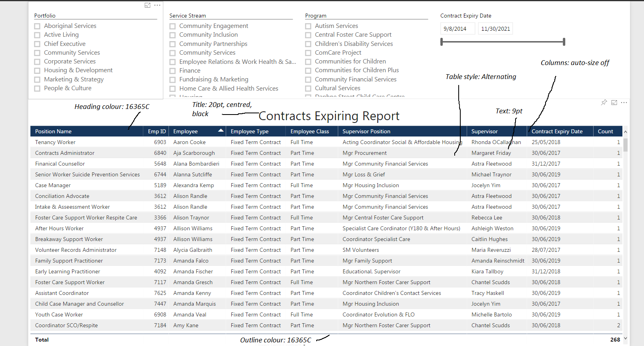

## Slicers

Put them at the top of the screen above any tables/charts.

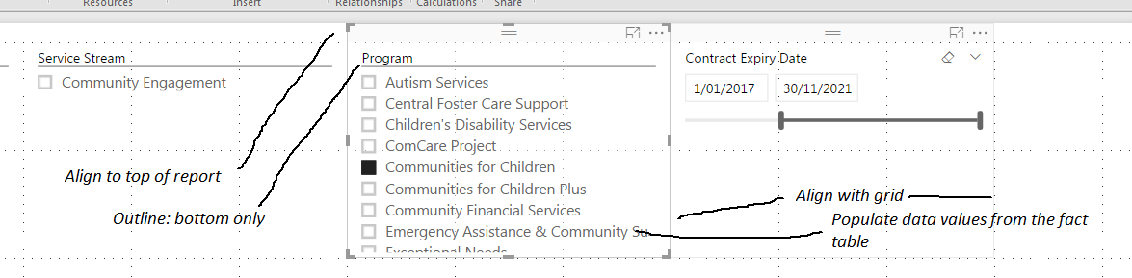

# Data Models

Ensure that you are using a dimensional model if reporting from the data warehouse. PowerBI works best with dimensional models, query performance is excellent and the model is optimised for reporting. Avoid using additional data tables in the model, everything you need should already be in the model, if it’s not, consider changing the underlying data model.

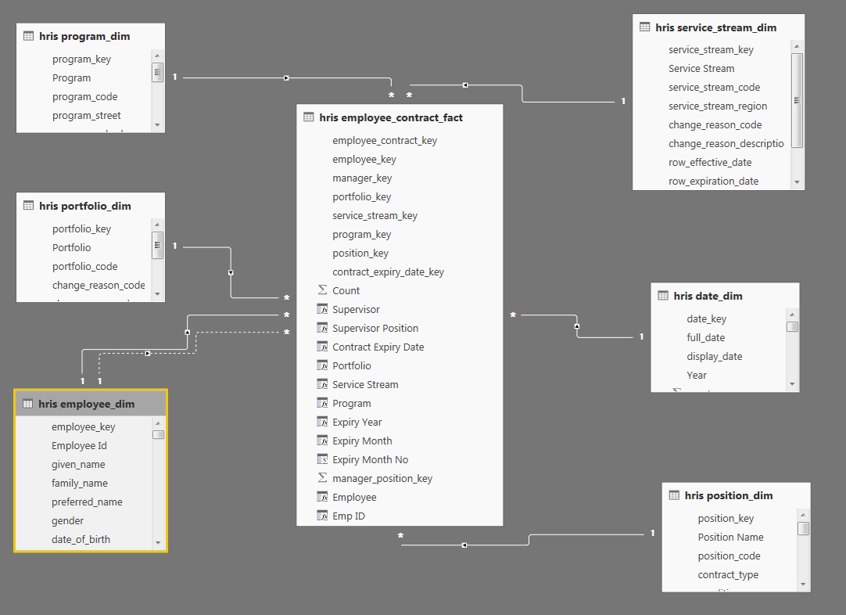

Slicers should be populated from the fact tables, not the dimensions. This means you have to add extra columns to the fact table and then populate them with values from the dimensions. The main reason you do this is to make sure your slicer is only populated with values that exist in the data.

E.g. Employee – step 1: create an Employee column on the employee_dim

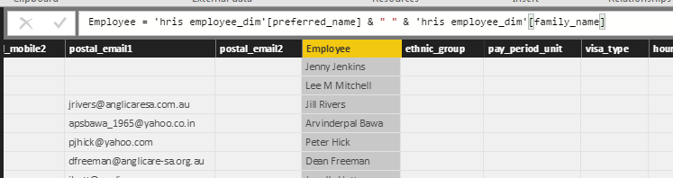

Step 2: add the Employee to the fact table

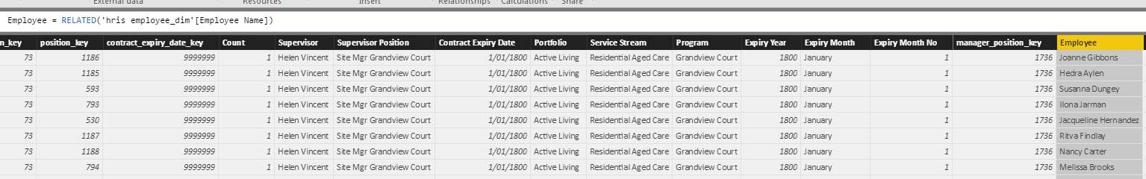

Step 3: use the Employee on the fact table to populate the slicer

